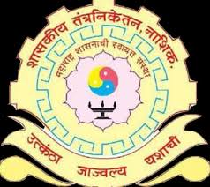
GOVERNMENT
POLYTECHNIC NASHIK
Department of Electrical
Newsletter
Editor- Mr. M. P. Bodke
Co-Editor-Ms. Shivani
Vyavhare
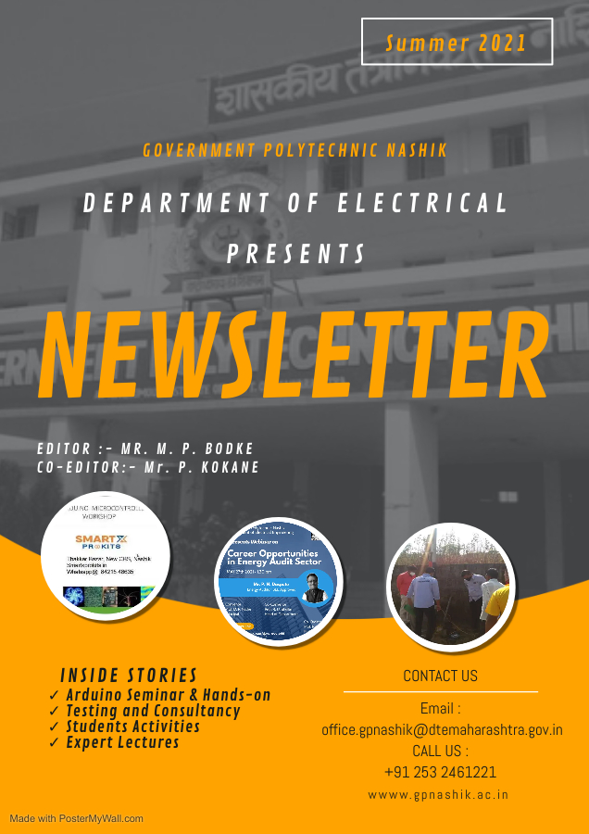
Covid :19 Students Industrial Pandemic Activities Visits
Summer20

Page 4 page6 Page 9
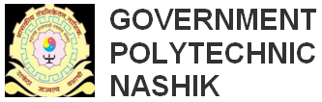ELECTRICAL ENGINEERING DEPARTMENT
Summer 2021

OUR VISION

To be the center of excellence in the development of manpower, entrepreneurship and technology meeting the diverse needs of the customer. The department shall be the technology center for electrical engineering works thereby meeting the skill and testing requirements in the electrical engineering technology in business and industry.

OUR MISSION

Department of Electrical Engineering is committed
M1. To provide diploma level technical education so as to equip learners with skills related to entrepreneurship, lifelong learning and employability.
M2. To disseminate knowledge with practical exposure ensuring, ethical, professional and safety Practices to meet the needs of industry and society.
M3. To be updated through self-evaluation and continuous improvement.
M4. To be acquainted with the modern trends and technology in electrical engineering field through testing and consultancy work and continuing education.
2
From HOD’s Desk
Summer 2021
It gives me immense pleasure to publish Summer 2021 newsletter.
In the even term of academic year 2020-21, various Expert lectures of eminent personalities from various fields were organized. The students also visited industries in online mode in order to achieve the PO’s.
Our department has been proactive in COVID-19 pandemic outrage. As the impact of this pandemic, to get acquainted with the online teaching, faculties attended online FDPs and Webinars. Our faculties completed the curriculum efficiently using various online platforms, virtual classrooms and V-labs. In order to test the competencies of the students, regular online MCQ tests/assignments/quizzes were conducted.
This was possible because of hard work and efforts of our staff and persistent guidance, encouragement of our beloved Principal Shri .Nathe Sir.

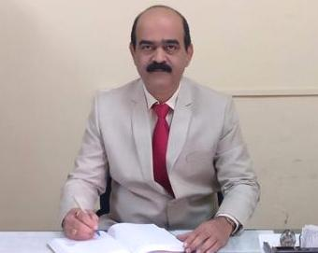

Prof. Rajesh U. Shelke
HOD EE Department.
3
Highlights  4  1. Arduino Seminar & Hands-on  Open-source electronic prototyping platform enabling users to create interactive electronic objects.  Mrs. M. P. Bodke of Electrical Department has organised a seminar on use of Arduino software. Arduino is an open source electronic Platform based on easy to use hardware and software. Arduino boards are able to read inputs-light on a sensor, a finger on button, or a twitter message and turn it into an output – activating a motor, turning on a LED, publishing something online.  This seminar was given by Mr. Amit Lelurwale of SMARTX PROKIT8, Nashik third year electrical engineering students. This software is very useful for students for their final year project based on programming.  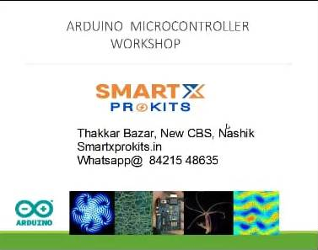  Testing and Consultancy |  |  | 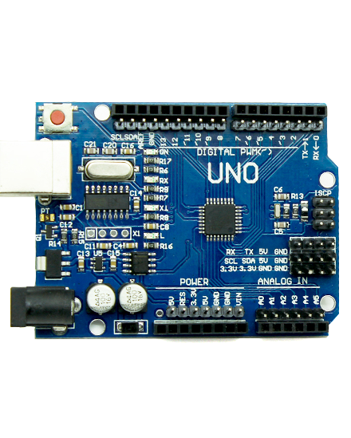  Summer 2021  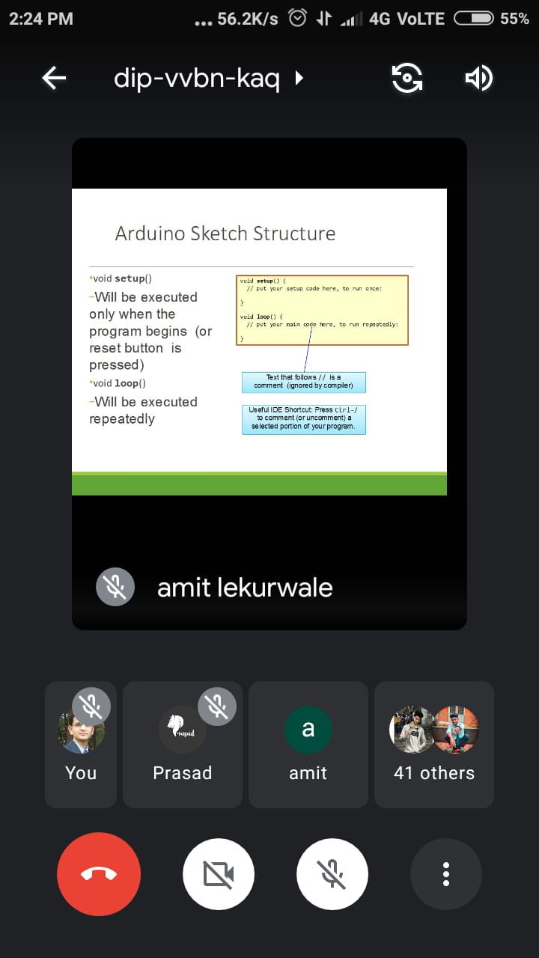
 |  |  | 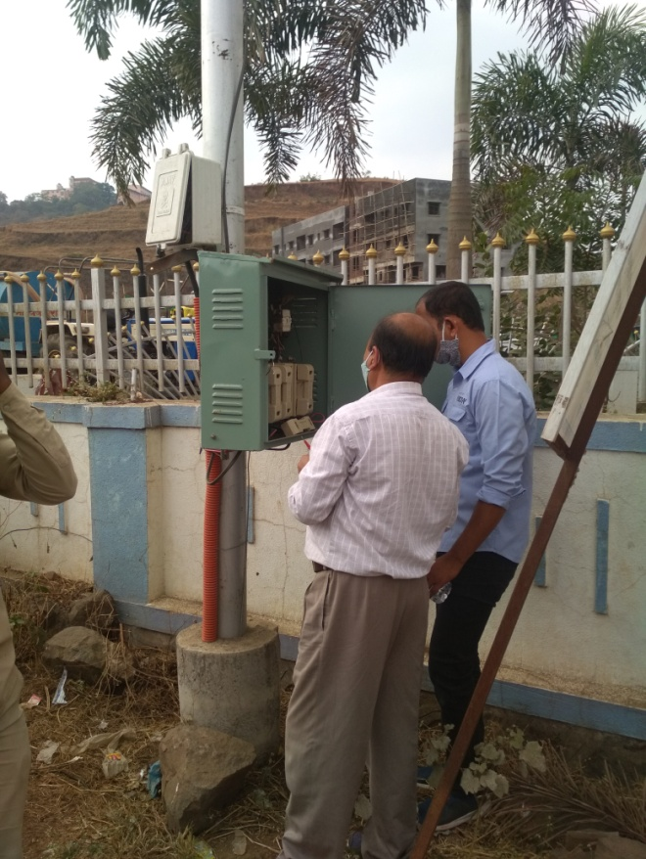
Department of Electrical Engineering conducts Testing and Consultancy assignments. This help for upgrading the industrial knowledge and generating revenue.
We provided testing forelectric lamps, choke, contactors, cables and wires &consultancy services for Motor Testing, UPS testing.This gave us an opportunity to work along with the Government Suppliers and contractors for Zilla Parishad, Municipal corporation Nashik, Tribal Development Commissioner, District Info. Officer Nashik and a few times private industries.
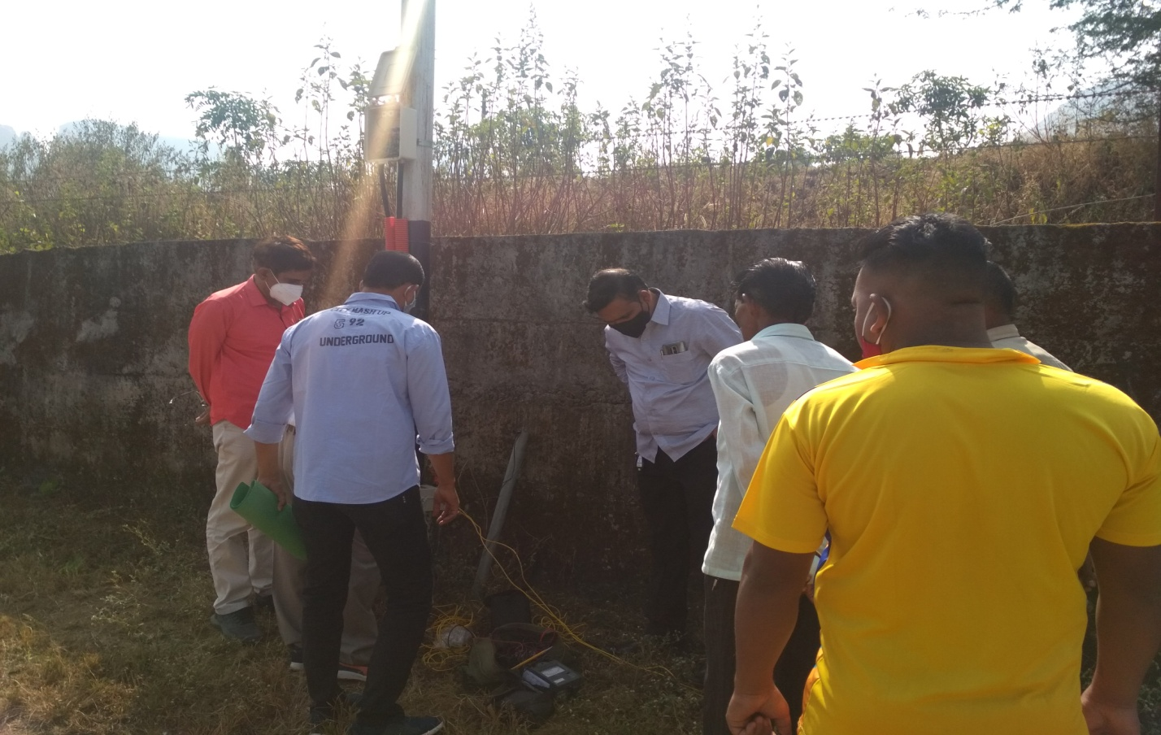
Summer 2021
5
 |  | Summer 2021

4. Students Activities
Our department student secured various accolades
6
In academics, sports, project competitions, social gathering..
- Jyoti prabhakar waje student of SYEE has participated and qualified in a State level Online E-Quiz Event on “Creativity, Innovation and Entrepreneurship” organized by Department of Mechanical Engineering of MET’s Institute of Technology-Polytechnic, Nashik from 19th May to 24th May 2021.  - Mr. Ashish Ramkishan Gitte has participated and qualified in Online “Environment Awareness Quiz”. Organized on the occasion of “World Environment Day - 2021” which is registered under United Nations World Environment Day Events |  | - Gosavi Priyanka Mahendra has participated and qualified in “State Level Project Competition” organized by Department of Electrical Engineering , MAP, Nashik held on 7th June 2021.
Expert Lectures  7 |  |  | Summer 2021
Expert Lecturer with proven expertise in a topic adds credibility to students’ learning’s. Hearing new voices provides students different point-of-view over the industry working and market overview, safety.
- Expert lecture on “Career Opportunities In Energy Audit Sector” by Mr. Pramod Daspute Sir was arranged on 27th may 2021. In this lecture students got the knowledge about various fields and opportunities in Energy Audit Sector.  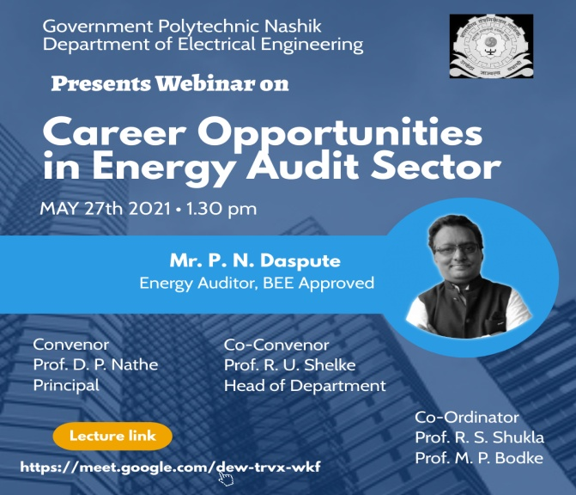  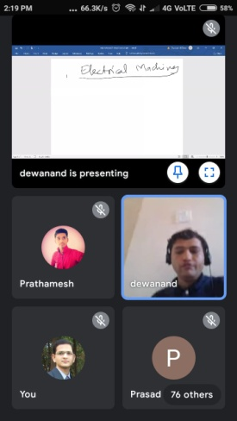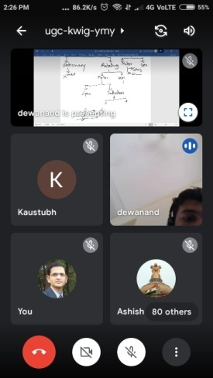 |  |  | 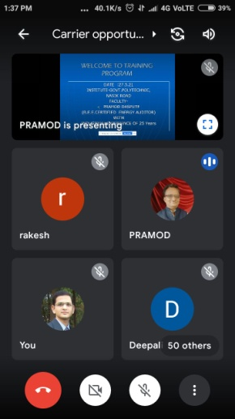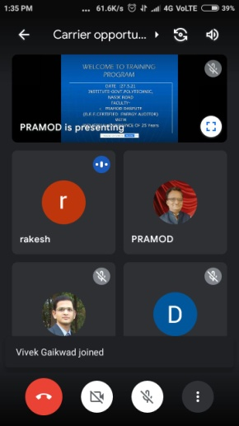  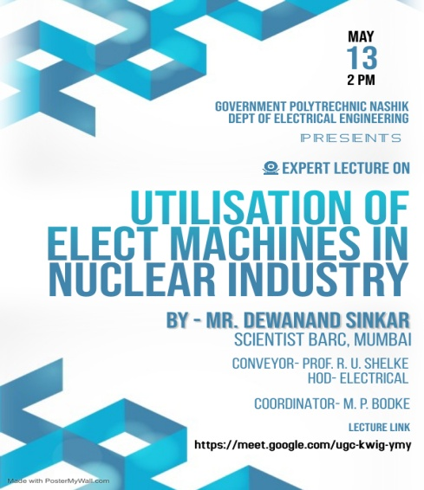  - Expert lecture on topic “Utilisation of elect machines in Nuclear Industry” was organised for SYEE & TYEE Students by Mr. Dewanand Sinkar Sr. Scientist BARC, Mumbai. Students were given detailed knowledge about nuclear industry.
Electric cooker:
An easy, efficient way to sanitize N95 masks,
study finds

A new study found that 50 minutes of dry heat in an electric cooker decontaminated N95 respirators inside and out while maintaining their filtration and fit. This could enable wearers to safely reuse limited supplies of the respirators.
The University of Illinois, Urbana-Champaign study found that 50 minutes of dry heat in an electric cooker, such as a rice cooker or Instant Pot, decontaminated N95 respirators inside and out while maintaining their filtration and fit. This could enable wearers to safely reuse limited supplies of the respirators, originally intended to be one-time-use items.
Led by civil and environmental engineering professors Thanh "Helen" Nguyen and Vishal Verma, the researchers published their findings in the journal Environmental Science and Technology Letters.
N95 respirator masks are the gold standard of personal protective equipment that protect the wearer against airborne droplets and particles, such as the coronavirus that causes COVID-19.
"A cloth mask or surgical mask protects others from droplets the wearer might expel, but a respirator mask protects the wearer by filtering out smaller particles that might carry the virus," Nguyen said.
High demand during the COVID-19 pandemic has created severe shortages for health care providers and other essential workers, prompting a search for creative approaches to sanitization.
8
15

