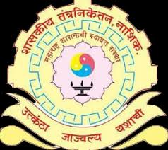
GOVERNMENT POLYTECHNIC NASHIK
Department of Electrical
Newsletter
Editor- Mr. M. P. Bodke
Co-Editor- Mr. Prasad
Kokane
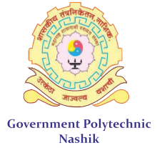
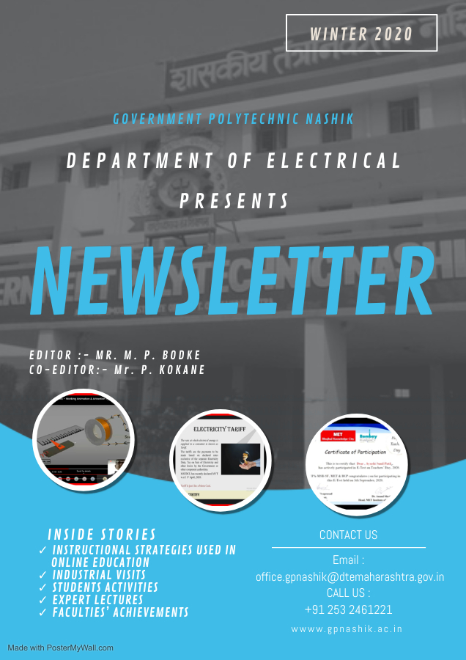
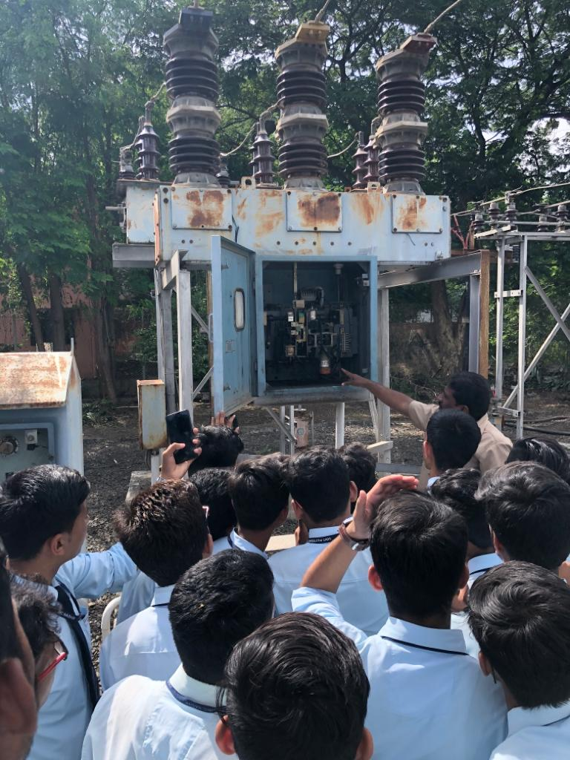
School Students Industrial Connect page 6 Visits
Winter 20

Page 4 Page 9
ELECTRICAL ENGINEERING DEPARTMENT

VISION

To be the center of excellence in the development of manpower, entrepreneurship and technology meeting the diverse needs of the customer. The department shall be the technology centre for electrical engineering works thereby meeting the skill and testing requirements in the electrical engineering technology in business and industry.

MISSION

Department of Electrical Engineering is committed
M1. To provide diploma level technical education so as to equip learners with skills related to entrepreneurship, lifelong learning and employability.
M2. To disseminate knowledge with practical exposure ensuring, ethical, professional and safety Practices to meet the needs of industry and society.
M3. To be updated through self evaluation and continuous improvement.
M4. To be acquainted with the modern trends and technology in electrical engineering field through testing and consultancy work and continuing education.
From HOD’s Desk:

Dear students and faculty members,
As the world goes through pandemic, we hope you, as well your family and friends are staying safe. The second wave of pandemic put immense stress on our students, parents and all stake holders. Every day, we are trying out a new approach in teaching-learning, engaging the students in meaningful and creative activities like organizing online webinars, Expert lectures, and virtual visits, publishing research papers for the benefits of students. In all of this, what keeps us going is the enthusiasm of our students, parents, alumni and faculties.
We conducted online practical and end semester examination for the students. Some students and their family members found positive, some are hospitalised and some are isolated at home. Few of our faculties were also infected. But in this situation also our academics completed successfully on scheduled time. During all these processes, we aimed to build confidence in students and which results in good score. We are proud of our students.

Let us Hope for a better tomorrow for all of us.

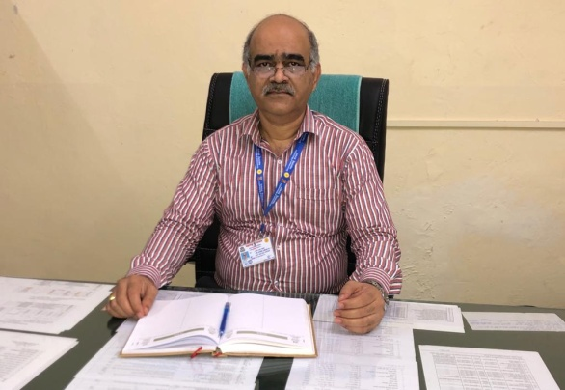

Prof. R.U. Shelke
HOD EE Department.
Highlights |  |  | 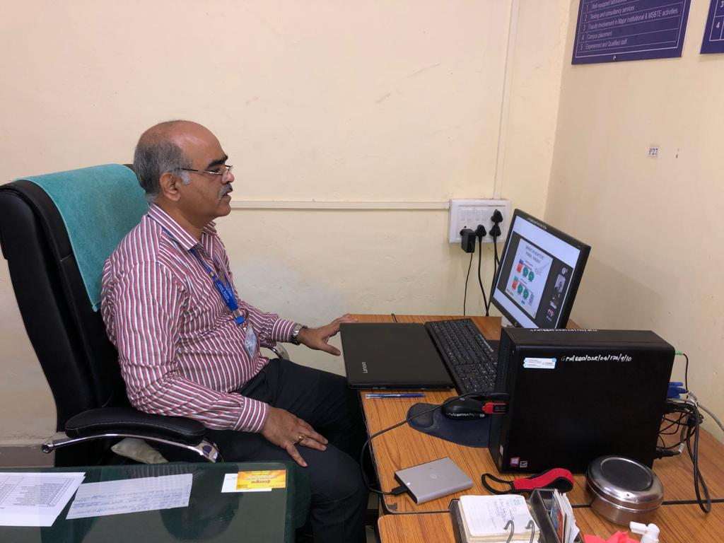
Instructional strategies used in online education.  Online Lecture  Lecture is perhaps the most prevalent instructional strategy used in higher education—on campus and online. Just as they would in a classroom, many online professors use lectures to transmit information, promote comprehension, and spark students’ interests. Learning management systems typically allow instructors to record lectures, deliver them live, or both.  Discussions  - Whether used in conjunction with lectures or as a separate learning exercise, class discussion supports learning and actively engages online students in the learning process. Learners have an opportunity to ask questions and communicate their ideas while practicing analytical and cognitive skills. Many students feel more comfortable participating in discussions than in the classroom. |  |  | 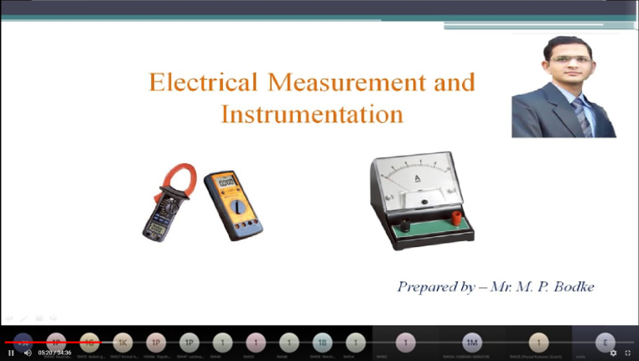  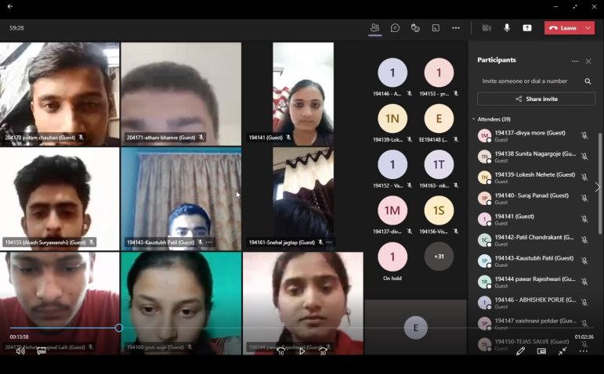
3.Demonstrations  - Teaching by showing is just as prevalent in online courses as traditional ones. Demonstrations are a mainstay when it comes to conveying certain concepts and processes. They are also among the instructional methods enhanced by the virtual learning environment. Online instructors frequently upload recorded video demonstrations to the LMS regardless of whether they delivered them synchronously or asynchronously. Students can review these clips as often as necessary to master the lesson.  4.Simulations  - Simulations delivered in a realistic digital environment allow online students to test practical skills and knowledge remotely. Major colleges sometimes use simulations to prepare online students for fieldwork. Preparing simulations was once a lengthy, tedious process, but leading LMS platforms can streamline the process by allowing instructors to choose from a variety of scenarios that complement course content. |  | 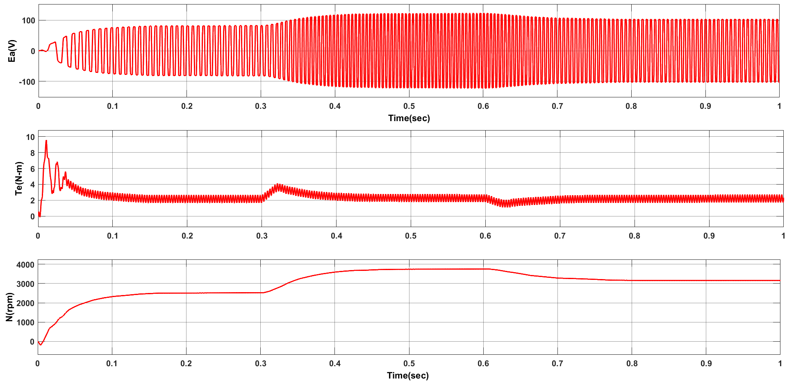  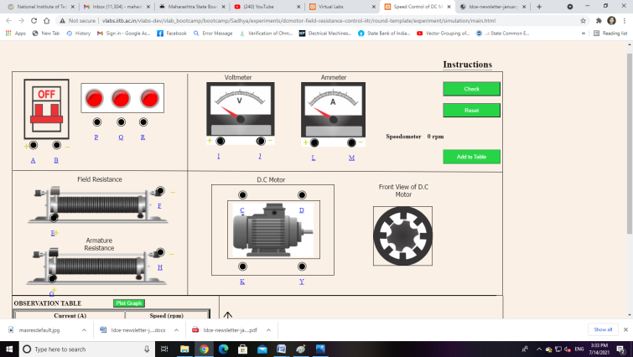  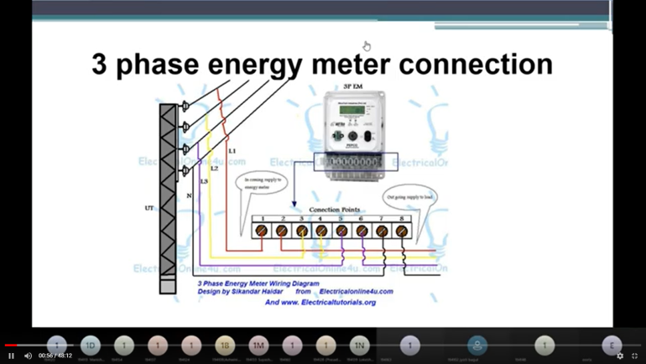  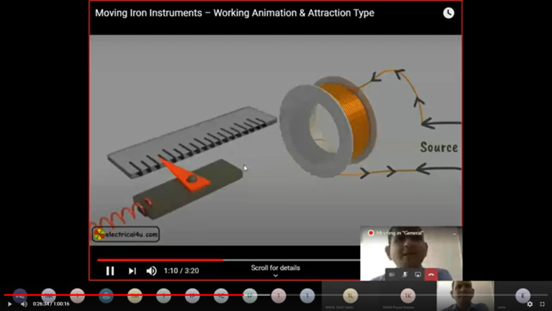
5.Games  - Like simulations, games let online students gain practical experience in an accessible digital environment. They can also increase student participation as learners may find them more engaging and less stressful than simulations. Educational technology developers integrate game-building applications directly in the LMS to simplify the design process.  6.Case Studies  - Case studies are another instructional method that places students in an active learning role while promoting research, problem-solving, and high-level cognitive skills. When used in a collaborative way, these exercises present another opportunity for online students to connect and learn from one another. It can be helpful for instructors to suggest reputable online resources students can consult for information. case studies work well in online courses and do not require much preparation. |  |  | 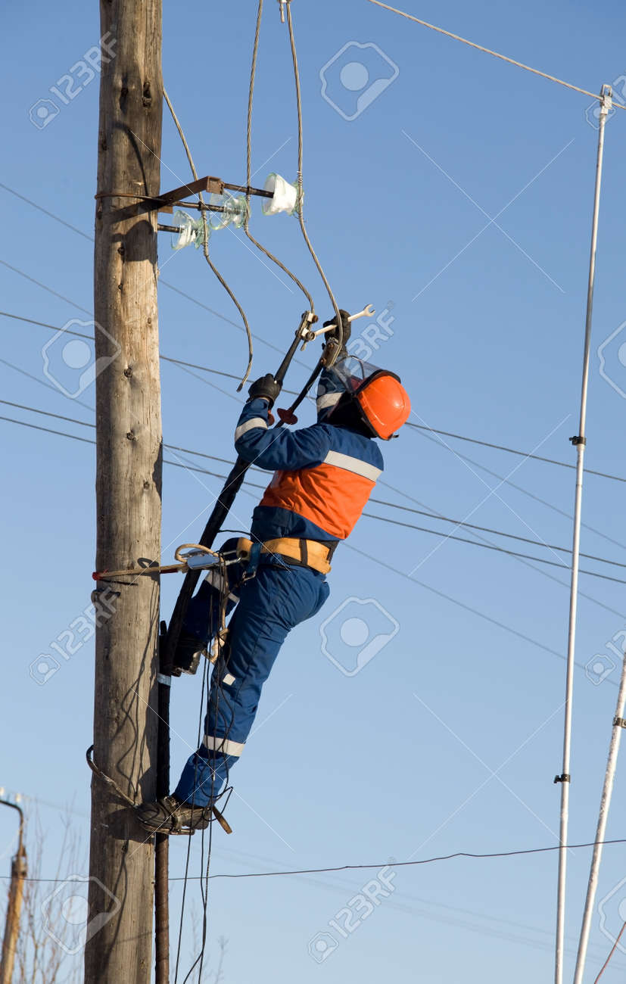  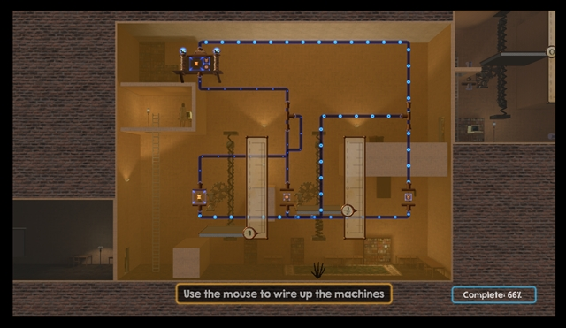  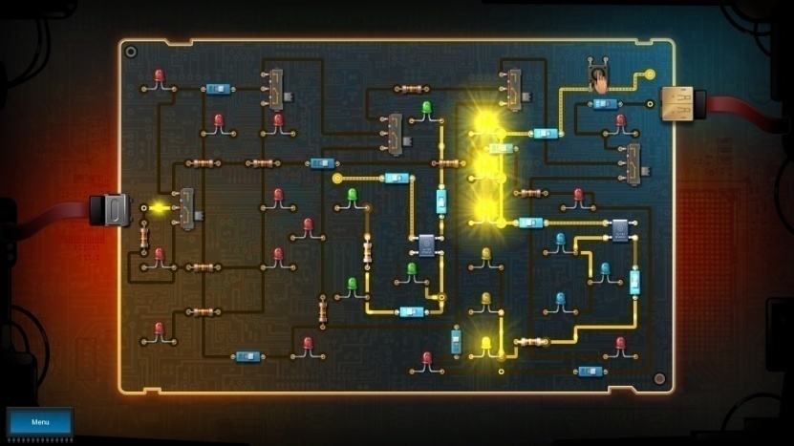

Students Activities
Achievements of students from Department of Electrical Engineering in terms of academics, sports, project competitions, social gathering.

- Miss Shital Kailash Waje students of the 3rd Year has participated and secured FIRST rank in “Innovative ideas of projects” organised by SND college of Engineering and Research center Yeola.

- Mr. Balaji Atmaram Punjare, students of the 2nd Year has participated in Online Quiz Competition based on “life of Dr APJ Abdul Kalam”, Organized by RDTC Shri Chhatrapati Shivajiraje College of Engineering on the occasion of former president Dr. APJ Abdul Kalam's birth anniversary celebrated as ‘Vachan Prerna Divas’ held on 15th October 2020.

- Miss. Sonawane Sakshi Bhausaheb students of the 2nd Year has participated in Online “Environment Awareness Quiz”. Organised by K. K. Wagh Polytechnic, Nashik, on the occasion of “World Environment Day - 2021” which is registered under United Nations World Environment Day Events.

- Miss Siddhi Dineshkumar Ubale students of the 3rd Year has participated in “State Level Project Competition” organized by Department of Electrical Engineering , MAP, Nashik held on 7th August 2020.

- Miss Shruti Ratan Mandlik, student of the first Year has participated successfully in the State Level Poster Presentation Competition organized by Civil Engineering Department, Government Polytechnic, Karad on the occasion of WORLD ENVIRONMENT DAY.

- Mr. Panad Suraj Dilip student of the 2nd Year has participated in Online “Environment Awareness Quiz”. Organised by K. K. Wagh Polytechnic, Nashik, on the occasion of “World Environment Day ” which is registered under United Nations World Environment Day Events.

- Miss. Ayushi Sunil Patil, students of the 2nd Year has participated in Online Quiz Competition based on “life of Dr APJ Abdul Kalam”, Organized by RDTC Shri Chhatrapati Shivajiraje College of Engineering on the occasion of former president Dr. APJ Abdul Kalam's birth anniversary celebrated as ‘Vachan Prerna Divas’ held on 15th October 2020.

- Miss. Ayushi Sunil Patil student of the 2nd Year has Successfully completed Electrical Safety Awareness Quiz’’ organised by department of Electrical VIP Sangamner.

- Mr. Mahajan Rakesh Gopal student of the 2nd Year has participated in Online “Environment Awareness Quiz”. Organised by K. K. Wagh Polytechnic, Nashik, on the occasion of “World Environment Day - 2021” which is registered under United Nations World Environment Day Events.

- Miss. Ayushi Sunil Patil student of the 2nd Year has participated in Online “E Quiz”. Organised by IPA-MSB-SF, MET and BCP, on the occasion of “Teachers Day - 2020” held on 5th September 2020.

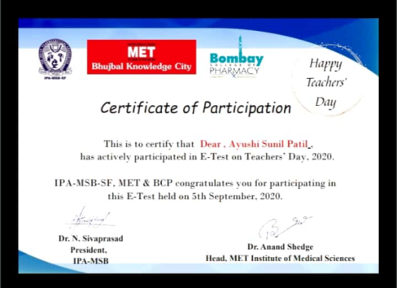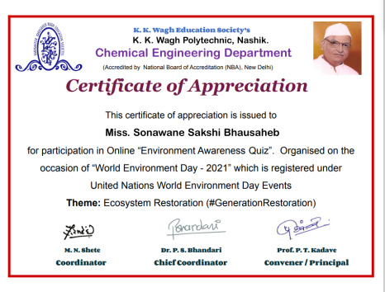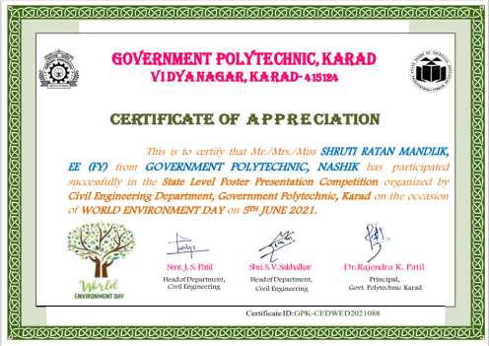
Industrial Visits
Industrial visits are considered as one of the tactical methods of teaching. The main reason behind this, it lets student to know things practically through interaction, working methods and practices.

- Virtual Industrial visit of Third Year Electrical students was organized to 220/110/33 kV substation of MSETCL at Karad. In this visit students got practical exposure to working of isolators and circuit breakers etc. Also students learn the layouts of substation and working of transformer. | - Virtual Industrial visit of Third Year Electrical students was organized to 132/33 kV GIS substation. This Substation was contained within a sealed environment with a dielectric gas known as SF6. During this visit students learn about Overview of a GIS System, Advantages and Disadvantages of GIS Systems.

Expert Lectures
Expert Lecturer with proven expertise in a topic adds credibility to our content. Hearing new voices provides students not only with different points-of-view, but also with potential resources they can apply in later courses.
- Department of Electrical Engineering has organized an expert lecture on ‘Electricity tariff’ by Mr. Daspute Sir, Energy Auditor, Nashik Students got knowledge about various Components Electricity tariff.  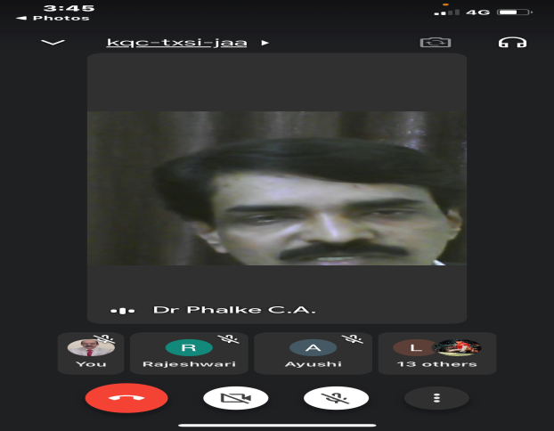  - Expert lecture on ‘Smart Grid Technology’ by Mr. Kulkani sir was organised by the MSBTE so that students gets aware about software training required at the industry level. |  | 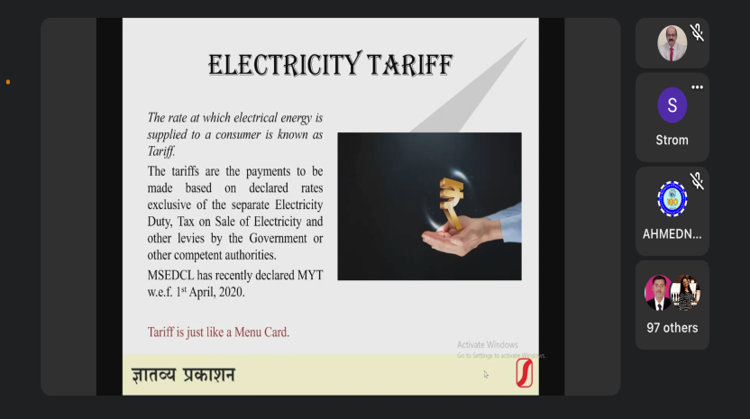  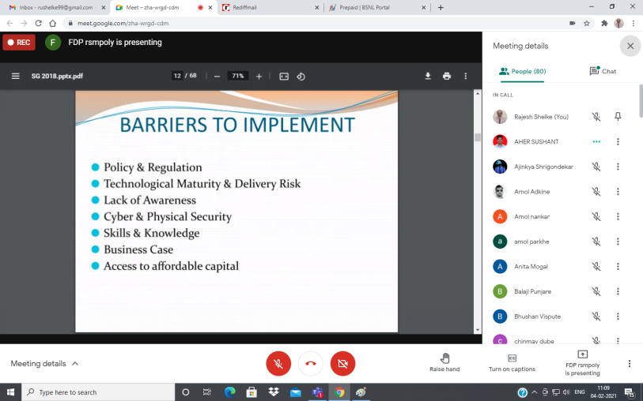  - Expert lecture on ‘Electrical safety’ was organised for Students of Electrical Department. It was delivered by Mr. C. A. Phalke (Deputy Executive Engineer MSEDCL Nashik). This lecture helped students to aware about practices to be followed while working n industry.

Faculties’ Achievements

- Prof. R. U. Shelke has Participated in state level faculty awareness programme through E-Quiz on “Outcome based Education (OBE) and Administrative policies” organized by MET’s institute of technology-polytechnic Nashik.

- Departmental Faculties Mr. S. S. Ashtaputre, Mr. R. S. Shukla and Mr. M. P. Bodke Actively Participated in Oxygen Inspection and Audit under taken by Govt. of Maharashtra in dealing with Covid-19 Pandemic.

- All Departmental Faculties Actively Participated in School Connect Program Organized by DTE Mumbai. More than 750 students have been contacted.

- Mr. M. P. Bodke. Successfully completed the course ‘Orientation towards Technical Education & Curriculum Aspects’ with a consolidated score of 88% (Course duration 8 weeks: Sept-Oct 2020) (NPTEL-AICTE Faculty Development Program).

- Mr. M. P. Bodke. Successfully completed the course ‘Professional Ethics Sustainability’ with a consolidated score of 84% (Course duration 8 weeks: Sept-Oct 2020) (NPTEL-AICTE Faculty Development Program).

- Mr. M. P. Bodke. Successfully completed the course ‘Communication Skills, Modes and Knowledge Dissemination’ with a consolidated score of 77% (Course duration 8 weeks: Sept-Oct 2020) (NPTEL-AICTE Faculty Development Program).

Publications/ Papers presented
- R. U. Shelke, M. P. Bodke, R. G. Srivastava, “Review on Selection of Fuel Cell for Powering Electric Vehicle”, International Journal of Research in Electronics and Computer Engineering (IJRECE), ISSN: 2393-9028 Vol.08. Issue 4, Oct- Dec 2020.

Abstract-The scientific world of automotive technology in present state is more concerned towards eradication of the fossil fuel based Internal combustion engine, and the traction system needs a substitute which is both eco-friendly and economical. These concerns have mounted due to issues of pollution and finite status of fossil fuel, and conventions related to global climate change. Engineers have focused into seeking a clean and sustainable energy source for our ever increasing energy demands. Alternate fuel systems like Hydrogen, Ethanol from Biomass, and others are looked around for the optimal replacement of fossil fuels, particularly in the domain of transportation sector which houses the quantum consumption globally.
Fuel Cell Technology is seen as good option for supporting the Electric vehicle scenario, which also acts as a replacement for the internal combustion engine system. There are many Fuel cell technologies based on different cell configuration and fuel used. The best design for Electric vehicle is still a point of debate, and it is likely to be different for various combinations of operating conditions, working loads and desired sizes.

- M. P. Bodke, R. G. Srivastava, S. S. Khule “ANFIS-MPPT Control Algorithm for a PEMFC System used in Electric Vehicle Applications”, The Research Journal (TRJ) , ISSN: 2454-7301 Vol.06. Issue 6, Nov- Dec 2020.

Abstract− Fuel cells are power sources that have a relatively high energy density and use a renewable fuel as its primary energy source, that is, the hydrogen. Therefore, they are often considered as an ideal candidate for a zero emission vehicular applications due to their low operating temperature which makes them well suited for personal vehicle applications. The output power of a fuel cell is immensely dependent on cell temperature and membrane water content. A maximum power point tracking controller is essentially required to extract the optimum power from the fuel cell stack. In this paper, a control scheme is planned to effectively absorb power from fuel cell stack. The power system also needs to be designed to suit the operation inside the module of Electric vehicle. Here, adaptive Neuro-fuzzy inference system (ANFIS) based maximum power point tracking controller is testified for a proton exchange membrane fuel cell (PEMFC) system can be used in electric vehicle applications. In order to extract the optimum power, a high step-up boost converter is connected between the fuel cell and the BLDC motor.. The performance of the proposed controller is tested under normal operating conditions and also for sudden variations in the cell temperatures of the fuel cell in MATLAB Simulink environment.

Professional Development
(Online STTP/FDP/Workshop/Conference etc. attended only)

Sr. No | Title | Organized By | Duration
Prof. R. U.Shelke
1 | IoT & Advanced Power Electronics Applications in Smart Grid Phase I | KKW COE Nashik  ACTE-ISTE Sponsored | 10/08/2020 to  14/08/2020
2 | IoT & Advanced Power Electronics Applications in Smart Grid Phase II | KKW COE Nashik  ACTE-ISTE Sponsored | 31/08/2020 to  2/09/2020
3 | IoT & Advanced Power Electronics Applications in Smart Grid Phase III | KKW COE Nashik  ACTE-ISTE Sponsored | 14/09/2020 to  18/09/2020
4 | Renewable Energy Sources | KKW Poly Nashik  ACTE-ISTE Sponsored | 07/12/2020 to  11/12/2020
5 | Use of Modern Tools and Computing Skills for Engineers and Researchers I | PCOE Nagpur  ACTE-ISTE Sponsored | 21/12/2020 to  26/12/2020
 | Use of Modern Tools and Computing Skills for Engineers and Researchers II | PCOE Nagpur  ACTE-ISTE Sponsored | 18/01/2021 to  23/01/2021
6 | Recent Trends in Renewable Energy Sources | RSM Poly, Nashik  ACTE-ISTE Sponsored | 01/02/2021 to 06/02/2021
7 | Environmental Challenges: Process & Pulp Industry | GCOE, Chandrapur  ACTE-ISTE Sponsored | 23/02/2021 to  01/03/2021
8 | Advancement in Renewable Energy | GCOE, Nagpur  ACTE-ISTE Sponsored | 17/03/2021 to  23/03/2021
Prof. S. S. umare
1 | IoT & Advanced Power Electronics Applications in Smart Grid Phase I | KKW COE Nashik  ACTE-ISTE Sponsored | 10/08/2020 to  14/08/2020
Prof. D. R. Kirtane
1 | IoT & Advanced Power Electronics Applications in Smart Grid Phase I | KKW COE Nashik  ACTE-ISTE Sponsored | 10/08/2020 to  14/08/2020
Prof. S. Y. Sanap
1 | Industrial training IIOT | National Small Industrial Corp Ltd | 16/03/2021 to 30/03/2021
Prof. M. P. Bodke
1 | Use of Modern Tools and Computing Skills for Engineers and Researchers | PCOE Nagpur  ACTE-ISTE Sponsored | 21/12/2020 to  26/12/2020
2 | Advancement in Renewable Energy | GCOE Nagpur  ACTE-ISTE Sponsored | 17/03/2021 to  23/03/2021

Science News
Scientists Find Bacteria That Eats Plastic

German researchers have identified a strain of bacterium that not only breaks down toxic plastic, but also uses it as food to fuel the process, according to The Guardian.
The scientists discovered the strain of bacteria, known as pseudomonas bacteria, at a dump site loaded with plastic waste, where they noticed that it was attacking polyurethane. Polyurethane's are ubiquitous in plastic products because they are pliable and durable. However, when they reach the end of their usefulness and end up in landfills, they decompose slowly and slowly release toxic chemicals into the soil as they degrade. They are also notoriously difficult to recycle, according to Courthouse News. Since it is so difficult to recycle, millions and millions of products containing polyurethane like sneakers, diapers, kitchen sponges and foam installation end up in landfills. Polyurethane usually kills most bacteria too, so it surprised the researchers to find a strain that not only survived, but also used polyurethane to thrive, according to The Guardian. The findings were published in the journal Frontiers in Microbiology.
"The bacteria can use these compounds as a sole source of carbon, nitrogen and energy," Hermann J. Heipieper, a senior scientist at the Helmholtz Centre for Environmental Research-UFZ in Leipzig, Germany and co-author of the new paper, said in a statement. "These findings represent an important step in being able to reuse hard-to-recycle polyurethane products."

