Faculty CV
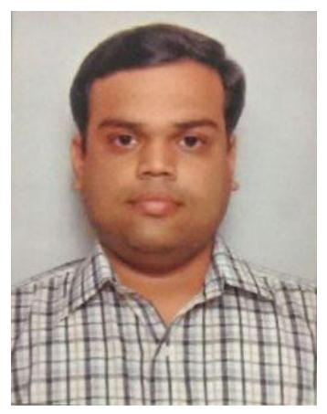
- Name of Faculty: GIRISH GAJANAN WANKHEDE
- Present Position : Lecturer in Civil Engineering
- Address : 303, Vraj Naitra Appt., Pipeline Road,
Nashik Maharashtra 422013
- Mobile No. : 8830690363
- E-Mail Id : wankhede.girish@gmail.com
- Date of Birth : 28 / 09 / 1985
5. Memberships of professional organizations/Bodies :

  - Indian Society for Technical Education ( ISTE)
LIFE MEMBER
QUALIFICATIONS:

Sr.  No. | Examination | Institute | Board/  University | % of  Marks | Class Award | Remark
1 | M.Tech. Civil  (Hydraulic & Water Resources Engg.) | Indian Institute of Technology, Madras | Indian Institute of Technology, Madras | 7.83 (CGPA) | First Class with Distinction
2 | B. E. Civil | MIT , Pune | University of Pune | 68.27 | First Class with Distinction
4 | H.S.C. | K R Kotkar Jr. College, Chalisgaon | M.S.B. of S. &H.S. Edu. MH | 76.50 | First Class with Distinction
5 | S.S.C. | New City High school, Dhule | M.S.B. of S. &H.S. Edu. MH | 80.00 | First Class with Distinction
ADDITIONAL SKILLS
CAREER DETAILS:

Sr. No. | Organization | Designation | Duration | Period | Work Done in Brief
1 | TATA Consulting Engineers | Engineer | 01/03/2010 to 30/06/2010 | 4 Months | Hydraulic Design of storm water drainage
2 | Sandip Foundation’s SITRC, Nashik | Asst. Professor in Civil Engineering | 30/07/2010 to 24/03/2012 | 1 Year 8 Months | Teaching and allied activities
3 | Government Polytechnic under Directorate of Technical Education | Lecturer in Civil Engineering | 16/05/2012 Till date |  | Teaching and allied activities

SPECIALIZED TRAINING COURSES ATTENDED:

Training Programmes / Seminars / Workshops / Courses Participated / Paper Presentation Girish Gajanan Wankhede
Sr. No. | Title of Training | Duration |  | Venue
 |  | From | To
 | Machine Learning and Deep Learning Applications in Engineering & Science | 16/05/2020 | 20/05/2020 | GOVERNMENT COLLEGE OF ENGINEERING KARAD (Online)
 | Recent Advances in Civil Engineering | 02/06/2020 | 07/06/2020 | Veermata Jijabai Technological Institute (VJTI), Mumbai (Online)
 | Effective use of ICT tools in teaching learning process | 08/06/2020 | 12/06/2020 | Govt Polytechnic Malvan (Online)
 | Advances in  Civil and Structural Engineering (ACSE - 2020) | 15/06/2020 | 19/06/2020 | GOVERNMENT COLLEGE OF ENGINEERING KARAD (Online)
 | Industrial Training in Artificial Intelligence and Machine Learning Using Python | 19/07/2021 | 02/08/2021 | NSIC (online)
 | Industrial Training | 02/08/2021 | 13/08/2021 | MSBTE and NIELIT (Online)

RESEARCH ACTIVITIES
Presentations and Publications in Refereed International Conference Proceedings

Presentations and Publications in Refereed National Conference Proceedings (Total__)

Reviewer for international Journals
WORK DONE IN THE AREA OF TECHNICAL EDUCATION
WORKSHOP/ COMPETITION ARRANGED
PROJECT GUIDANCE
- Guided Project at diploma level.
EXPERT TALK
WORK DONE AT ORGANIZATIONAL LEVEL
- Controller of Examinations- Autonomous Institute
- Officer In charge – Examination (Online Exam) – Autonomous Institute
- Officer In charge – Question Paper Moderation Committee (Online Exam) - Autonomous Institute
- Inspection of Institutions for MSBTE, DTE
WORK DONE FOR SOCIETY
OTHER WORK
HONORS AND AWARDS
RESEARCH /OTHER GRANTS

SIGNATURE

