Faculty CV
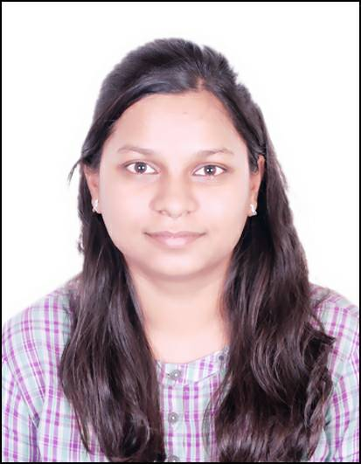
- Name of Faculty : Manisha Pratik Wakchaure
- Present Position : Lecturer in Information Technology
- Address : Government Polytechnic, Samangaon Road,
Nashik Road, Nashik (M.S.),
Pincode: 422 101.
4. Mobile No. : 9665402344
- E-Mail Id : manishawakchauregpn@gmail.com

QUALIFICATIONS:

Sr.  No. | Examination | Institute | Board/ University | % of  Marks/ CGPA | Class Award | Remark
03 | B.E. (CSE) | Government College of Engineering,  Aurangabad | BAMU, Aurangabad | 7.1 | Distinction

CAREER DETAILS:

Sr.  No. | Organization | Designation | Duration | Period | Work Done in Brief
01 | Government Polytechnic Nashik | Lecturer in Information Technology | 0.9 | 12/08/2021  to till date | Lecturer
02 | Puranmal Lahoti Government Polytechnic, Latur | Lecturer in Information Technology | 4 | 03/10/2011  To  11/08/2021 | Lecturer
03 | Datametica Pvt. Ltd., Pune | Software Engineer | 3 | 15/09/2014  to 29/09/2017 | BigData Engineer

SPECIALIZED TRAINING COURSES ATTENDED:

Sr No | COURSE/TRAINING TITLE | TRAINING PERIOD | TRAINING PLACE | TRAINING  SPONSORED AGENCY
1 | Induction Phase-I | 20/05/2019 to  31/05/2019  2 Weeks(12 days) | PLGP Latur | NITTTR, Bhopal
2 | Induction Phase-I | 02/04/2018 to  13/04/2018  2 Weeks(12 days) | NITTTR, Bhopal | NITTTR, Bhopal

WORK DONE AT ORGANIZATIONAL LEVEL

Sr. No | Position held | Period
1 | Coordinator, Curricular and co-curricular activities, Information Technology, Government Polytechnic, Nashik. | 2021 - till date
2 | Academic Coordinator, Information Technology, Government Polytechnic, Nashik. | 2021 - till date
3 | Member, Admission committee for centralized first year diploma engineering admission in Nashik District at Government Polytechnic, Nashik. | 2021-22

SIGNATURE

Smt. M. P. Wakchaure

