Curriculum Vitae

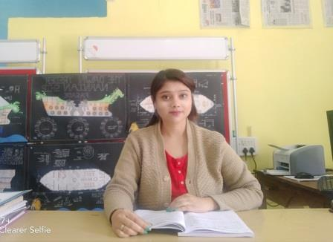
- Name of Faculty: Miss. Vishakha Sanjay Patil
- Present Position : Lecturer in IDD
- Address : Dept. of IDD,
Government Polytechnic Nashik
Samangaon Road, Nashik Road, Nashik
- Mobile No. : +91- 8999511142
- E-Mail Id : ar.vishakhapatil@gmail.com
- Date of Birth: 16-02-1991
- Memberships of professional organizations: Nil

QUALIFICATIONS:

Sr.  No. | Examination | Institute | Board/  University | % of  Marks | Class Award | Remark
1 | B. Arch. | J.N.E.C. Aurangabad | B.A.M.U | 69.00 | 1st class | Distinction
2 | HSC | D.D.S.P.College Erandol | PUNE | 78.88 | 1st class | Distinction
3 | SSC | R.T.Kabre Vidyalaya | PUNE | 77.77 | 1st class | Distinction

ADDITIONAL SKILLS
- Communication
- Ability to Work Under Pressure
- Decision Making
- Time Management
- Self-motivation
- Conflict Resolution
- Leadership
- Adaptability

CAREER DETAILS:

Sr. No. | Organization | Designation | Duration | Period | Work Done in Brief
1 | Govt. Poly. Nashik | Lect. In IDD | 09-09-2014 to till the date | 04years 3months | Teaching and I/C HoD ,Rector for ladie hostel
2 | Rachnashilp Architects and designers | Senior Architect | 02-08-2013 to 31-6-2014 | 10 months | Executed residential and commercial projects
03 | Navgire and navgire Assocates | junior Architect | 04-06-2012 to30-09-2012 | 04 months | Executed residential and commercial and landscape projects

SPECIALIZED TRAINING COURSES ATTENDED:

Sr. No. | Course Name | Duration | Place | Training Agency | Remarks
01 | Two weeks induction programme –phase 1 | 11-05-2015 to 22-05-2015 | Sandip Foundation Nashik | NITTTR ,Bhopal | --
02 | Six weeks foundation training programme | 21-07-2015 to 10/08/2015 | Yashada Pune | Govt.of maharashta (DTE mumbai) | --
03 | Two weeks induction programme –phase 1 | 06-06-2016 to 17-06-2016 | Bharti vidyapit Kharghar Mumbai | NITTTR ,Bhopal | --
04 | One week training programme on woman Empowerment | 19-12-2016 to 23-12-2016 | MSBTE Mumbai | NITTTR ,Bhopal | --
05 | One week – institutional Autonomy | 04-06-18 to 08-06-18 | NITTTR extension center Pune | NITTTR ,Bhopal | --
06 | Two days workshop on orientation of curriculum curriculum revision | 30-09-15 to 01-10-15 | Govt Poly. Nashik | NITTTR ,Bhopal | --
07 | One days workshop on flower arrangements and bonsai | 21-12-2014 | Surya hotel nashik | Alfa agro landscape services | --

RESEARCH ACTIVITIES
(Paper Publications)
- V. S. Patil, Effect of Cutting Parameters in Precision Turning of Nickel Alloy by RSM, International Journal for Research in Engineering Application & Management (IJREAM), Special issue, 2018, pp 412-416

WORK DONE IN THE AREA OF TECHNICAL EDUCATION
- Handling additional charge of rector since 12 th sept 2019 – govt poly Nashik
- Scrutiny and verification officer for FC and ARC centre 2015,16,17 govt poly Nashik
- Scrutiny officer regional office Nashik 2016
- Verification officer for MHT-CET (MCA)2016
- Subject expert for I scheme curriculum development for MSBTE Mumbai
- Scrutiny officer for ARC centre DSY 2016 admission
- Verification officer for Local Assessment centre G.P.Nashik. 2014,2015,2016,2017,2018
- Handling the charge of Head of Department for interior design and decoration department , Govt.Poly.Nashik

PROJECT GUIDANCE
- Designing of art gallery for 2nd yr students 2015- G.P.nashik
- Designing of library for 2nd yr students 2016- G.P.nashik
- Designing of music academy for 2nd yr students 2017- G.P.nashik

SIGNATURE

