Faculty CV
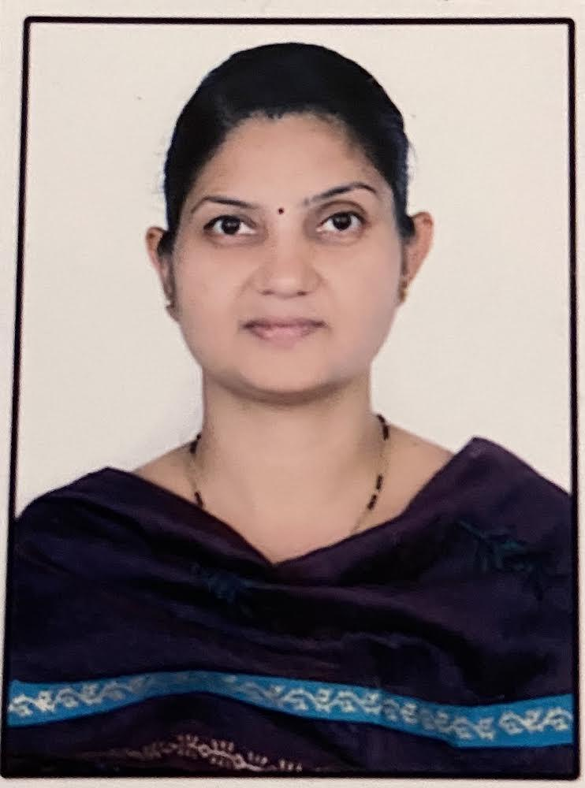

- Name of Faculty: YOGITA SUNIL PATIL
- Present Position: Lecturer in Physics
- Address : Dream nest Society, B/204, Tagore Nagar, Nasik,
- Mobile No. : 8805162358
- E-Mail Id : yswagh111@gmail.com
- Date of Birth : 20/05/1974
QUALIFICATIONS:

Sr.  No. | Examination | Institute | Board/  University | % of  Marks | Class Award | Remark
01 | SSC | JaiHind high school,Dhule | Pune | 76.14 | Distinction | -
02 | HSC | JaiHind Junior college dhule | Pune | 67.17 | First Class | -
03 | B.SC | . JaiHind Junior college Dhule | North Maharashtra University,Jalgaon | 71.3 | Distinction | -
04 | M. SC | North Maharashtra University,Jalgaon | North Maharashtra University,Jalgaon | 63 | First Class | -
05 | B.Ed | Mulji Jetha College,Jalgaon | North Maharashtra University,Jalgaon | 78.12 | Distinction

CAREER DETAILS:

Sr. No. | Organization | Designation | Duration | Period | Work Done in Brief
01 | S.M.I.T. Polytechnic, Jalgaon | Lecturer  in Physics | 05/08/2005to 07/08/2008 | 03 years | Teaching  Examination
02 | Govt. Polytechnic, Nashik | Lecturer  in Physics | 08/04/2008  To till date | 14 years | Teaching  Evaluation  Examination  Extracurricular activities
SPECIALIZED TRAINING COURSES ATTENDED:

Sr. No. | Course Name | Duration |  | Place /Training Agency | Remarks
01 | Induction Phase I | 6/6/2016 | 17/06/2016 | NITTTR,Bhopal | 2 weeks
02 | Environmental Pollution : Green and Alternative Fuels | 12/12/2016 | 23/12/2016 | NITTTR,Bhopal | 1 week
03 | Induction Phase II | 20/2/2017 | 03/03/2017 | NITTTR,Bhopal | 2 weeks
04 | Research Methodology and Optimization Techniques | 30/1/2018 | 03/02/2018 | Government Polytechnic, Nashik | 1 week
05 | Empowering Teaching Skills Using Modern Pedagogy Tools. | 14/01/2019 | 18/01/2019 | Government Polytechnic, Nashik | 1 week
06 | Emotional Inellingence | 27/01/2020 | 27/03/2020 | NPTEL | 8 week
07 | Simulation Techniques in Applied Science | 31/1/2022 | 4/02/2022 | Online NITTTR,Bhopal | 1 week
WORK DONE IN THE AREA OF TECHNICAL EDUCATION --
- G.P. Nashik of Curriculum Development
- G.P .Nashik Laboratory Manual Development
- G P Nashik Question Bank Development
Competition Arranged
- IEDSSA Girls Carrom and Chess competition
- Other Work
Cultural Activities SIGNATURE

