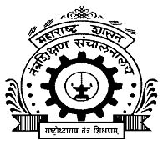 GOVERNMENT POLYTECHNIC, NASHIK.
(An Autonomous Institute Of Government of Maharashtra)

DRESS DESIGNING AND GARMENT MANUFACTURING

News letter

Volume -01 June –nov2014-15
Student’s achievements
- Shital Sangale , Shamali thok ,Kiran Dongare ,Priyanka Pawar, Shradha Mahajan students of third year won the third prize in “Pragya” National Level Competition, GGS Institute of Engg. Nanded3 March 2014.
- Patil Jayashri S., Sope Rakhi D., Sonawane Ruchita Y. students of second year participate in Technofest-2014” Garment Fair & Spontaneous Presentation G.R.W.P.Latur 13 & 14 sept.2014.
Events

Department organised paper presentation on different topics.
SR.NO. | TOPIC | Name of students | year | prize
01 | Paper Presentation Of “ Elementary Textile”  G.P.Nashik  15 sept.2014 | - Rahane Akshata A.  - Kaidal Shweta S.  - Ahire Ashwini B.  - Chavan Sushma K.  - Waghela Payal R | II ND | FIRST
02 | Paper Presentation On “ Retailing”  G.P.Nashik  15 sept.2014 | - Kashid Prajkta D.  - Araikar Kajal S.  - Ahire Manjushri P.  - Kurkure Shravika A.  - Patil Bhagyashri B. | IIIRD | SECOND
03 | “Elements Of Design Drawing” Competition  G.P.Nashik  15 sept.2014 | - Nichal Shweta M. | IST | THIRD

Expert lectures
SR.NO. | TOPIC | EXPERT | DATE | BENEFICIARIES
 | Fashion Accessories | Mrs.Smita Keluskar (Lect.in INIFD ) Nashik | 02/07/2014 04/07/2014
 | Role Of Textile In Antenna Engg | Mr.J.G.JoshiLect.In Electronics & Telecomm.  Govt.Polytechnic ,Nashik | 30/09/2014

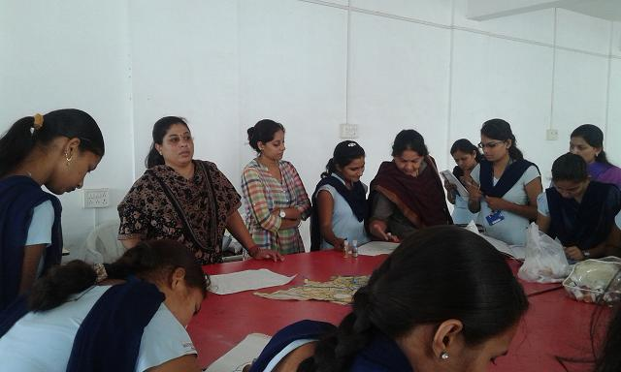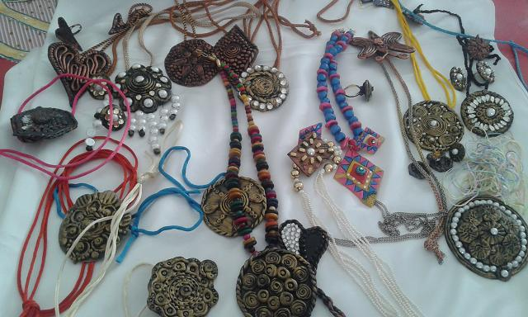

FASHION SHOW 2013-14

